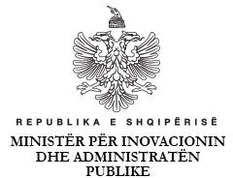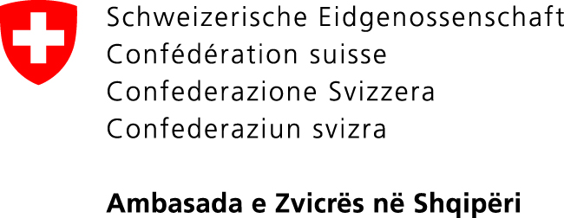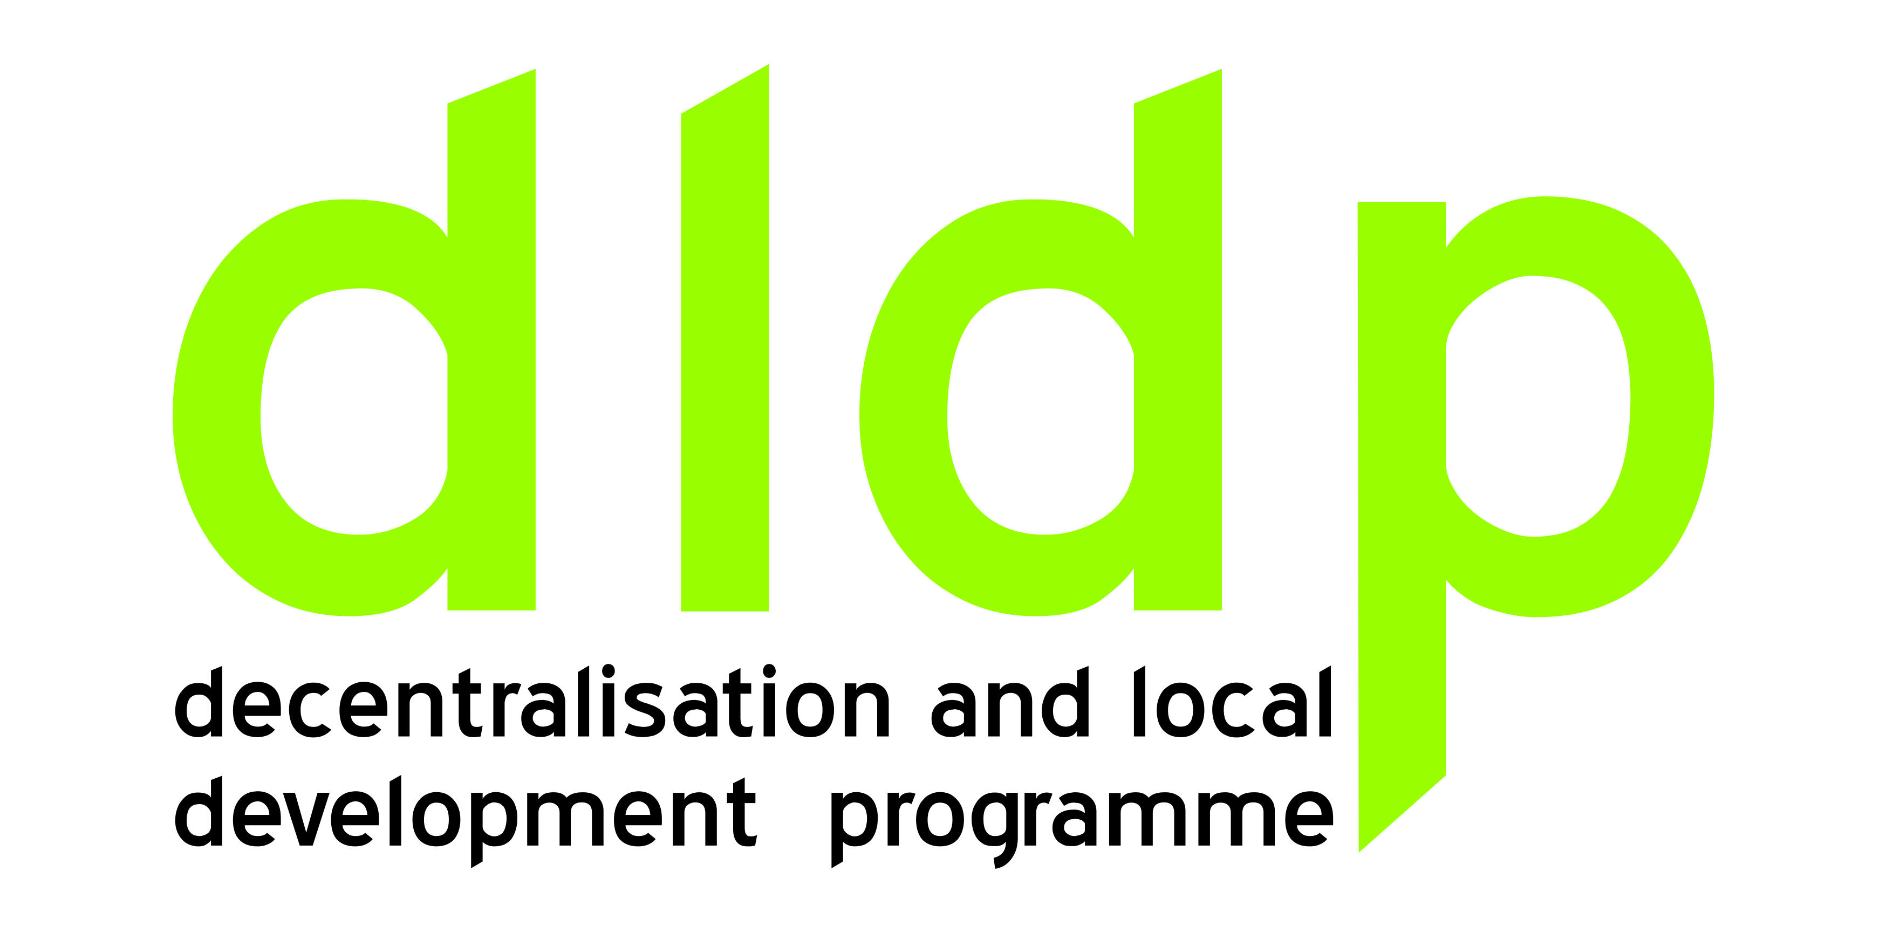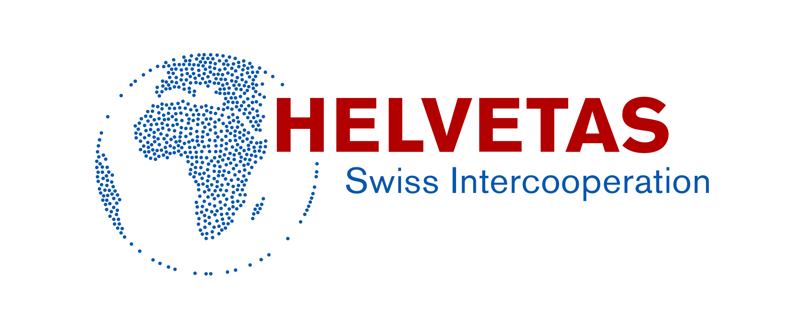

## REPORT

## OF

**THE NATIONAL CONFERENCE**

**CONSOLIDATION OF ADMINISTRATIVE AND**

**TERRITORIAL REFORME:**

***PRACTICES AND LEARNINGS***

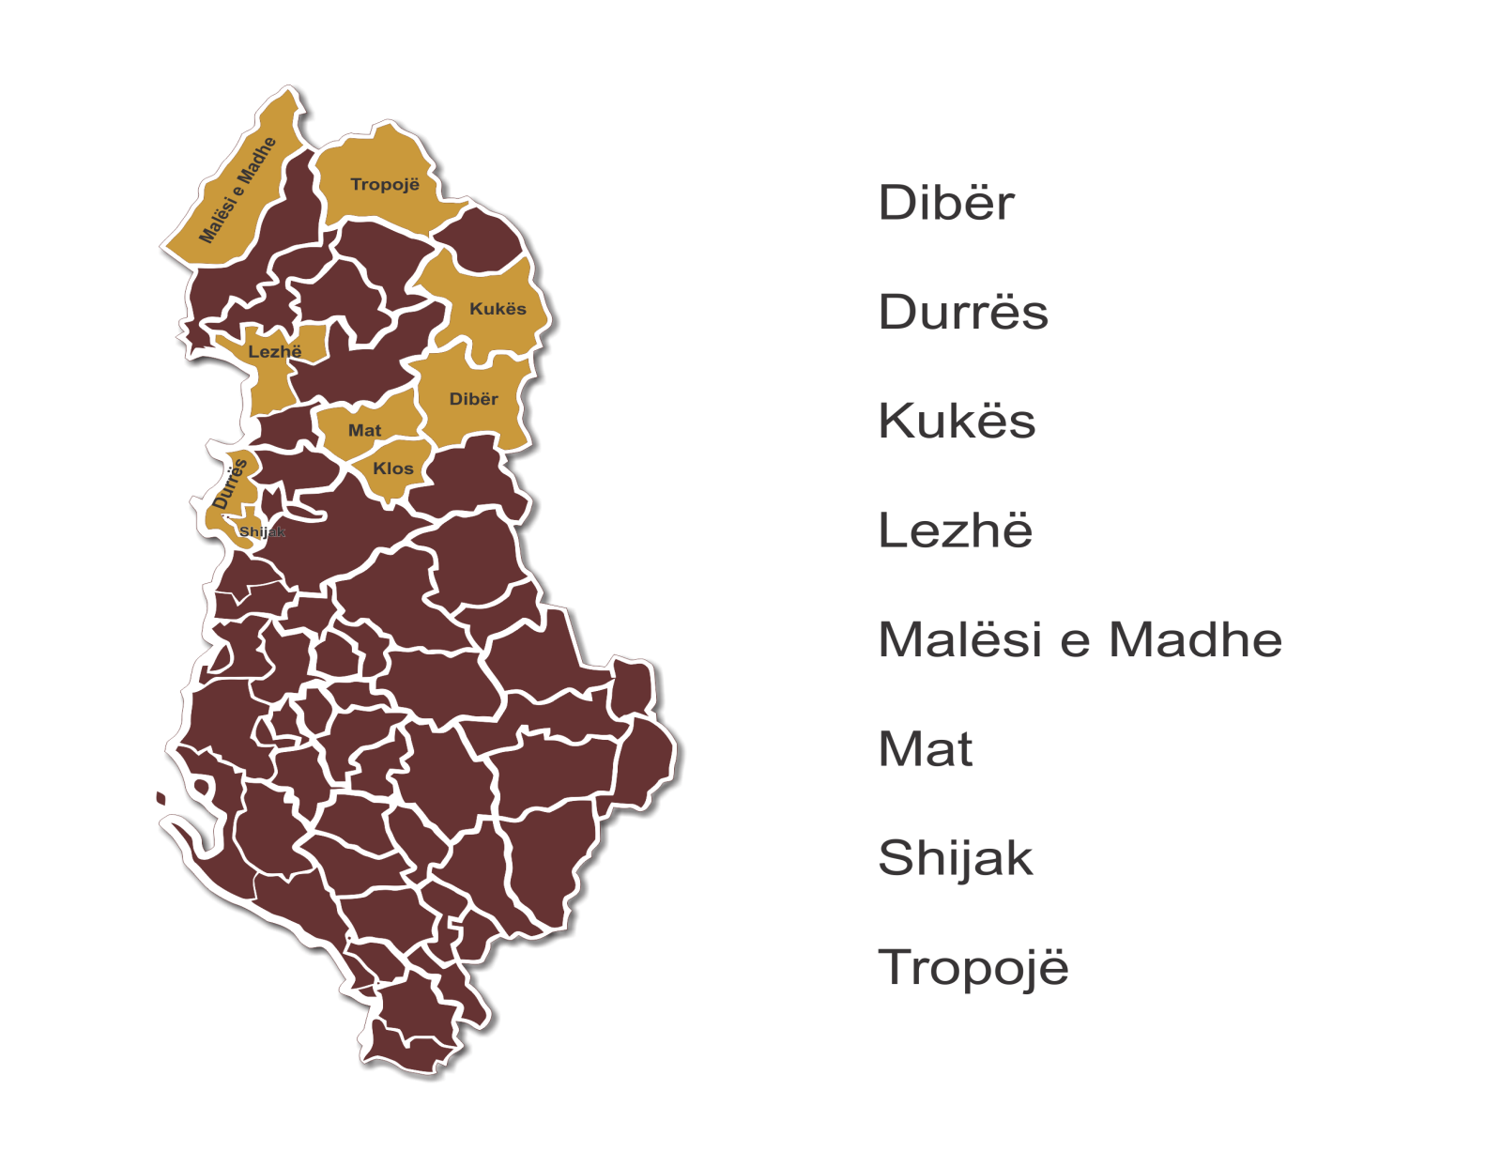

**Tiranë, May 2015**

This Report was prepared by Erton Kashta (dldp deputy program manager) and Arben Kopliku (dldp deputy program manager), with the support of Valbona Karakaçi (dldp program manager). The report expresses the opinions of dldp and of the authors, but not necessarily the opinions of the donor and the co-organizers of the Conference.

Contents

1. Executive Summary 4

2. General Frame 5

3. Participation and outreach 6

4. Session 1 (plenary): Opening and general presentation 7

Presentation 1 8

Movie 9

Presentation 2 9

Experts intervention 11

Findings and Recommendations of the Session 1 13

5. Session 2: Award ceremony and FAP exhibition 14

Best FAP awards 14

Best FAP implementing organizations’ awards 15

Functional Areas Programs Exhibition 15

6. Session 3: (parallel sessions) local planning & organizational development 16

Session 3A: Local Planning 16

Presentation: FAP vs Strategic Planning and its methodology 17

Interventions from panel members 18

Findings and Recommendations of Session 3A 20

Session 3B: Organizational Development 20

Presentation: Organizational chart of the new LGUs: learnings from FAP and practices from the Integrated One-Stop-Shops exercise. 21

Interventions from panel members 23

Findings and Recommendations of the Session 3B 24

Annex 1: Program of the Conference 25

Annex 2: Resources 25

# Executive Summary

Swiss Embassy in Albania through *Programme for Decentralization and Local Development* (dldp) implemented by Helvetas Swiss Intercooperation (HSI) in cooperation with Albanian Government supports different initiatives as response to the *territorial and administrative reform* (TAR), namely *Functional Area Programme* (FAP) and *Service Delivery* through innovation and organizational development.

FAP is implemented in the future LGU-s of Peshkopi, Burrel, Klos, Tropojë, Kukës, Lezhë, Durrës, Malësi e Madhe and Shijak, whereas integrated-OSSH is piloted in Kallmet and Lezhë (based on analytical findings of a broader group of LGU-s Vau i Dejës, Bushat, Shkoder, Dajç, Manëz, Durrës).

**National Conference “Consolidation of Administrative-Territorial Reform: Practices and Learnings”** has been designed as a platform for experience exchange on the above topics with various national and local stake holders based on gained know-how, which should also contribute to the policy discourse about future functioning of local government units.

The awarding of efforts and good practices culminated in a ceremony: three prizes on FAP were intended for committed LGU-s/communities and consultancy organizations as well as a Fair of local projects identified to mobilize the potential of TAR for local development took place. FAP and identified projects have been assessed by local experts, citizens and groups of interests, through an all-inclusive and transparent process. Evaluation has served for drawing conclusions and recommendations on strategic planning for future LGUs.

The Conference was organized in a first plenary session and two parallel thematic sessions.

* The first session presented the concept of the Functional Area Program, the FAP preparation methodology and lesson learned from the implementation of the FAP in the eight pilot FA-s and the processes involved thereto, including the presentation of conclusions and recommendations concerning the identification as well as challenges in the preparation and implementation of projects.
* Service providers engaged by dldp expressed their view on the implementation of FAP, the opportunities and challenges faced in transforming the FAP methodology into a more concrete document.

During the two thematic sessions

* The Influence of good practice in local planning (moderated by Minister of Urban Development); and
* The organizational development of the new LGUs was discussed considering conclusions from FAP and Integrated One-Stop-Shop (moderated by Director of Department of Public Administration).

Presentations were made by dldp and its experts, while various resource persons and stakeholders discussed in each of the sessions. At the end, a wrap up with overall conclusions of the conference were presented.

### Some key conclusions from the conference are summarized below:

* FAP is seen as an appropriate tool for planning which can be used by LGUs as a response to the transitory period until the consolidation of TAR and the new LGUs themselves.
* The methodology of FAP validates the bottom up approach and the forums of citizens come as a very important instrument that supports developments. This is also very much in line with the new organic law where this new instrument for bringing forward the voice of citizens in decision making will be adopted.
* The projects and Programs of FAP should be revisited with the new Mayors and Council in order to bring about a better harmonization and coherence and political legitimacy.
* In the framework of the regional development set as a priority by the Government, the projects identified within the frame of FAP once fully developed could be a good basis for those municipalities.
* The new municipalities will manage bigger territories and plan for local development; however they should pay attention also to the regional development aspects. To this regard the approach provided by FAP is a good start and we need to strengthen the partnership between local and central government to engage in bigger scale projects with impact beyond local government units. An important aspect is to make these projects eligible for funding by the Regional Development Fund.
* FAP is very valuable for the knowing of the territory. It has the appropriate flexibility to be considered as a basis for analysis which serves to build strategic planning processes, which are a first step towards the realization of the general local plans. It is necessary to underline the importance of the qualitative dimension of this process. The economic analysis is very important to be carried out because it serves as an instrument which enables the acknowledgment of the territory.
* It is necessary to prepare a model structure for the new Municipalities as well as a manual on working procedures, on how they are correlated and how services are offered to the citizens.
* Introducing new key positions and structures will increase efficiency and transparency of the new Municipalities’ activities. For example the role of the Secretary General (which is already foreseen in the Cvivil Service Law).
* Certain structures, such as IT and Communication sectors need to be strengthened, given the role that such sectors will gain in the new Municipalities for assuring transparency and effectiveness.

# General Frame

**National Conference “Consolidation of Administrative-Territorial Reform: Practices and Learnings”** has been designed as a platform for experience exchange on the above topics with various national and local stake holders based on gained know-how, which should also contribute to the policy discourse about future functioning of local government units.

The Government of Albania has introduced the Territorial and Administrative Reform, which creates 61 Municipalities and will enter into force after the local elections of 2015. TAR has been introduced with a main objective of promoting the economic development at the local level, improving the services to the citizens and increasing the efficiency of the local administration.

TAR presents opportunities for the new LGUs, however new mayors are expected to face challenges, in creating first of all, the necessary conditions for a socio-economic cohesion of the new territories and population.

Local government related reforms initiated in the country (Decentralization Strategy, new organic law, law on local finances) should contribute to strengthening of local government for maximizing own potentials and resources, as well as for performing according to standards and requirements.

Functional Area Program comes as a planning instrument which will aid new Mayors and LGUs to identify the main sectors with potential for development, making use of the opportunities offered by a greater territory and more resources (economy of scale).

The Conference has been organized through the cooperation of the Minister of State for Local Issues, the Ministry of Urban Development, the Minister of State for Innovation and Public Administration, and the Embassy of Switzerland.

Ministry of Local Issues is considered as a key stakeholder for the harmonization of the ongoing efforts for the implementation of the TAR. Ministry of Urban Development leads governing policies in urban planning, including impact at local level. Minister of State for Innovation and Public Administration has given priority to development of One-Stop-Shop approach for providing services to citizens, as well as to public administration reform through Department for Public Administration.

Participants invited to the Conference were representatives of the local stakeholders who have helped to implement the Functional Area Program in 8 Functional Areas, through the support of dldp and Government of Switzerland. Space has been given to dldp experts engaged in implementing the FAP, as well as to representatives of institutions, organizations and programs which are contributing in the implementation of the TAR and the improvement of local governance.

Conclusions and recommendations have been provided for each session and the Conference.

# Participation and outreach

Participation was high gathering more than 100 experts, politicians and practitioners from the Ministry of Local Issues, the Ministry of Urban Development, the Minister of State for Innovation and Public Administration, Ministry of Finance, Department for Strategy Coordination, Department of Public Administration, the SDC Country Office in Albania, Municipalities, Communes and Qarks from all over Albania, Regional De-concentrated Agencies, Prefectures, Donor Agencies, Embassies, other projects and programs, national and international consultants, dldp team.

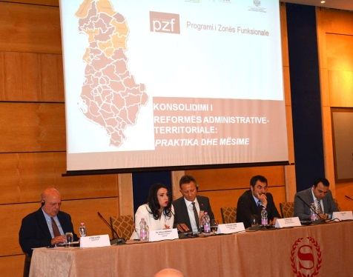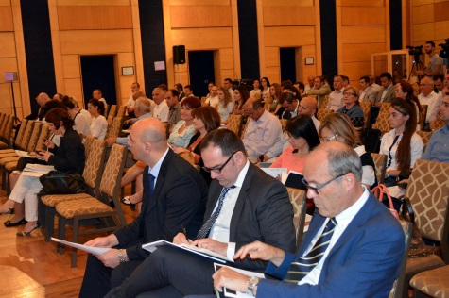

Participants were distributed the Methodologies of Functional Area Program, prepared on the framework of dldp. Catalogs with identified projects under each Functional Area Program have been also distributed to participants in both Albanian and English. All publications reflect the good practices developed in the framework of dldp program in northern Albania and serves as a guide for all practitioners, LGUs and other institutions.

During the conference two 5,000 Euro awards were given to Kukës and Lezhë for their commitment and innovative projects during the pilot phase of the Functional Area Programme. In addition, three organizations that provide support services were also awarded with prizes of 2,500 Euro – DEA Consulting and ALCDF – and 1,000 Euro for ANTARC. The prizes are part of a grant fund that rewards local government units and service providers participating in the Functional Area Programme set up by the Swiss programme.

The conference was honored by the presence and active contributions of Mr. Bledi Çuçi, Minister of State for Local Issues; Mr. Christoph Graf, Ambassador of Switzerland in Albania; Mrs. Eglantina Gjermeni, Minister of Urban Development; Mrs. Albana Koçiu, Director of Department of Public Administration. National and international experts contributed with their presentations and interventions.

The conference was covered by written and electronic media (some of the links below):

<http://www.oranews.tv/vendi/cuci-me-reformen-territoriale-shpetuam-nga-falimentimi-njesite-vendore/>

<http://www.shekulli.com.al/p.php?id=258204>

<http://scan-tv.com/v/index.php/lajme/nga-vendi/13030.html>

<http://gazeta-shqip.com/lajme/2015/05/12/reforma-e-decentralizimit-do-te-jete-me-e-qendrueshme-me-ndarjen-e-re/>

<http://www.balkanweb.com/site/gjermeni-mzhu-do-te-ndihmoje-njesite-vendore-per-planet-e-pergjithshme/>

# Session 1 (plenary): Opening and general presentation

The conference was opened by Prof. Dr. Valbona Karakaçi, dldp Program Manager, who explained the objectives of the Conference and introduced the different sessions and presentations.

Minister of State for Local Issues, Mr. Bledi Çuçi, in the quality of chair and co-organizer of the Conference greeted the participants. Mr. Çuçi stressed the particular importance of the Territorial and Administrative Reform (TAR) for the development in the new local government units, presenting greater opportunities and greater resources. He appraised the contribution of dldp, initially with the introducing of the concept of “functionality”, which has been on the basis of TAR and now with this new instrument of Functional Areas Program, which aims to contribute in the implementation of TAR.

*Bledi Çuçi: The territorial reform is the basis for sustainable socio-economic development of our local government and communities. The 61 new municipalities will have maximum support from the government which has taken all measures for implementing the reform after the local elections of 21st of June, including the new decentralization strategy, the new local government law, and financial support through the transition fund. I thank the international partners for supporting local government reforms and in particular the Swiss government which has shown a continuous engagement in decentralization and local government.*

Swiss Ambassador in Albania, H.E. Christoph Graf, also co-organizer of the Conference, greeted all participants and pointed out the necessity to support the implementation of TAR. Mr. Graph mentioned the various projects supported by Swiss government and congratulated dldp for the achievements up to now. He considered TAR as presenting three main advantages: improved services to the community, greater administrative efficiency and empowerment of the local government.

*Christoph Graf: Albania has just reorganized its territorial and administrative units. This is a big step that bears opportunities for a better administration of the country. But it also brings challenges and obstacles that we have to tackle together... It’s time to see this reform applied. It’s time to make it more than just a map and turn it into tangible benefits for Albanian citizens all over the country.*

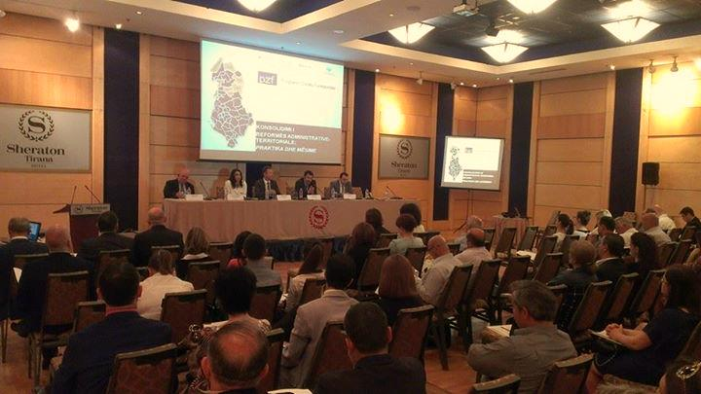Session 1 continued with presentations and discussions by resource persons.

Two presentations were planned for the first session: (i) Functional Areas Program (FAP) – Concept and Process, presented by dldp Program Manager, Dr. Valbona Karakaçi; and (ii) Functional Areas Program (FAP) – results of identified projects, presented by dldp Deputy Program Manager, Mr. Erton Kashta. A short movie prepared with FAP implementing organizations offered to the audience some information on opportunities and challenges of this Program.

### Presentation 1

Dldp Program Manager, Dr. Valbona Karakaçi held a presentation on Concept of FAP and the processes involved thereto.

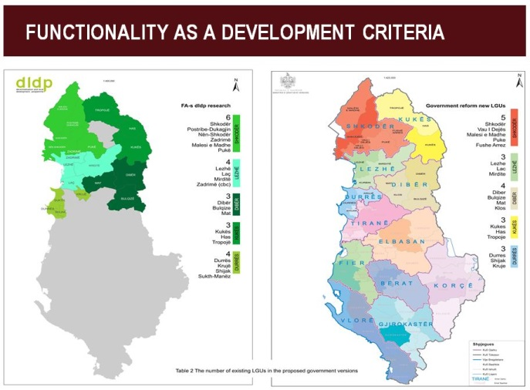The Functional Area Programme (FAP) started from the Functional Areas research in the five regions of dldp 3 focus. The FA research identified and measured several interaction variables (*economic, social, administrative, leisure etc*.) amongst communities across administrative borders. The FA research identified the FA potential borders and respective options in the five regions. The FA remains a criteria investigating development potential beyond borders, following up dynamics at any level they take place.

Based on these findings dldp 3 started piloting of the Functional Area Programmes (FAP-s) in five regions of North Albania (around 30 % of population). By understanding of the interaction dynamics through in depth analyses in a given FA, FAP serves as a basis to identify a group of projects that will *facilitate-initiate-intensify* these interactions.

What is expected from the FAP output/product ready for national replication is a Guiding document/Methodology which provides for:

* Scenarios of development for eight FAs
* Scenarios for service delivery for eight FAs
* Bundle of priority projects per each LGU
* Selected recommendations on organizational development.

A considerable work has been done at the local level:

* During October 2014- April 2015, dldp worked intensively for the preparation of eight FAPs: Malësi e Madhe, Lezhë, Durrës, Shijak, Kukës, Tropojë, Dibër and Mat (Klos).
* Nine LGUs will have an important document to delineate the development prospects as well as a group of important projects identified.
* The best FAP for two typologies are evaluated from a multi stakeholder jury (16 members, 50% development programmes and 50% ministries and national agencies).
* The FAP will be re legitimized with the new LGU-s after elections and selected projects will be funded through a grant system.

Public has been actively involved in the process of FAP. The FAP preparation process combines a robust technical expertise component with the public participation. Public participation is ensured through: a) The FAP forum including the representatives of different interest groups (*34 forums with 750 participants*); and b) The public at large in the FA-s is reached through an intensive communication interactive campaign *(outreach of 830 persons*).

FAP delivered also identification and ranking of 105 projects. This process included:

* Public evaluation, i.e. ranking of projects in each FA;
* Technical evaluation, through use of 10 criteria (e.g. impact, maturity, cohesion, etc.).
* Consolidation of all info in an analytical data base;
* Short list of the top 3 rated projects per FA.

For the implementation of the pilot, Dldp cooperated with eight organizations (service providers) that created a valuable experience and contributed in FAP methodology: (1) Dea Consulting (FA Mat); (2) Europartners (FA Kukës); (3) ALCDF (FA Dibër); (4) URI (FA Malësi e Madhe); (5) ISB (FA Lezhë); (6) CDI (FA Durrës); (7) ANTTARC (FA Tropojë); (8) Studio D (FA Shijak).

### Movie[1]

The audience had the opportunity to watch a short movie prepared by dldp as a capitalization of the experience of FAP implementing organizations. Representatives of these organizations had explained some of the main opportunities presented by FAP in the areas they had worked, as well as the challenges faced by them in implementing the FAP and following the methodology provided by dldp. Overall, organizations believed that FAP is an appropriate instrument to be used by new LGUs for planning and development purposes. On the other hand, the major challenge for them was to apply and adjust the methodology of FAP, for better suiting it to the local context in each of the Functional Areas. Working with FAP has been rewarding and a very good learning experience, which can be put into good use in the future and a possible replication of such instrument, in the other new LGUs.

### Presentation 2

Dldp Deputy Program Manager, Mr. Erton Kashta held a presentation concerning the projects identified in the framework of FAP and their features.

It was noted that regarding the Financial Volume of the 105 projects (10-17 per FA), there were some interesting figures coming out:

* Total fund requirement is 39.1 mio. €;
* Four projects are bigger than 2 mio. €;
* Three roads cost 17.8 mio. €;
* ¾ of projects are smaller than 0.3 mio €;
* The overall estimated budget requirement for the best ranked project per FA (8) is 2.8 mio. € for the top three projects (24) is 5.4 mio €

Projects identified have a multi-stakeholders approach. Main funders have been also identified, with most projects eligible for various funders financing criteria.

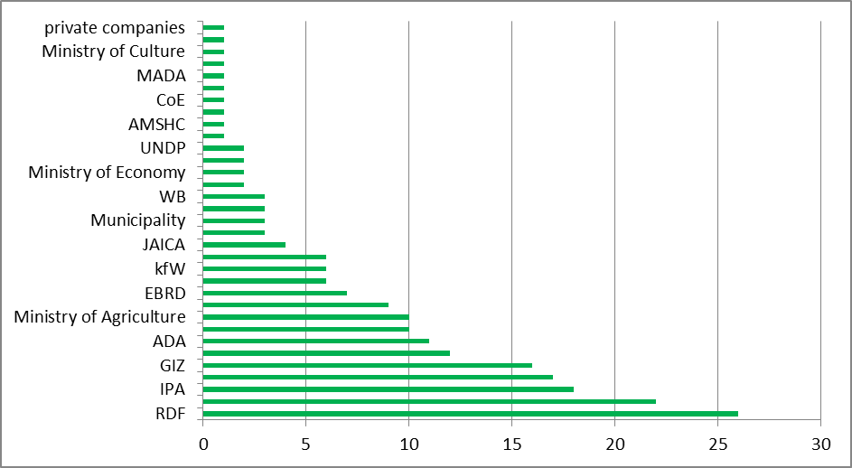

Main funders identified

As concerning the correlation with TAR, 15 of the best ranked projects contribute to it. Except a few, almost all projects are within the present definition of LGU functions (this includes a better definition of the projects of local economic development). Waste management and One Stop Shop projects have the biggest potential to support transition and sustainable development.

Project categories

There were 24 best ranked projects related to various sectors:

* 1/3 of the best projects are in the environmental sector (mostly waste management.
* Most have sectorial cross-cutting character;
* The top ranked projects are: 5 waste management, 1 afforestation, 1 market place development, 1 agro-processing.
* The ranking gap between the public and technical experts was highest for social and educational projects which are not part of the best rated projects.

Conclusions and recommendations coming out of the process of identification and evaluation of projects have been presented.

### Experts intervention

In Session 1, after the presentations from dldp, there were 4 experts discussing on the findings and recommendations.

**Mr. Peter Clavelle, chief of party of PLGP/USAID**: I thank Swiss embassy for inviting PLGP to be part of the Conference. Working together in providing assistance to LGUs in Albania, we have greater impact and involve stakeholders in policy dialogue. There is a lot of alignment of the work of dldp and PLGP. TAR provides opportunities and also challenges. FAP is one approach to face the implication of TAR and it can be linked with the local development planning and strategic planning. FAP in conjunction with other programs and strategies can in fact strengthen local government by improving services to citizens and by improving and capitalizing the opportunities for economic development, and as well offering to the citizens an opportunity to have their voices while decisions that affect their life are made. I agree with the key points that were made by dldp with the recommendations of today. Hopefully the decentralization strategy that will soon be approved by the Government will provide a road map and a coordinated approach as well as creating a sequence of the steps that must be taken. A number of good projects have been identified and deserve a funding. There is a need for greater clarity of the projects and how they will be funded and one of the Government’s priorities is to creating a funding mechanism for local economic development and for improved service delivery. This can be done through the support of the funding from regional development program as well as from other funding mechanisms for local investments. As local authorities cannot use the borrowing as an instrument it is important that other mechanisms are in place and understood by local government assuring their predictability. It is important to point out that in projects for agricultural processing and tourism there is a need for cooperation between local and central officials and that such cooperation needs to be organized and promoted and responsibilities clearly defined. Predictability of funding for exercising actual functions is more important that adding other functions. Expectations for services delivered by local government far exceed the resources, so there is a need to fill this gap, through a reform of the grant formula as well as through making the property tax a more reliable for local government finances.

**Prof. Stefan Pffaefli of the University of Luzerne (Switzerland):** TAR is a huge step forward towards improved condition for decentralized policy making and more professionalism at local level. However further steps must follow in a logical and combined way. We are speaking about reallocation of functions and allocation of adequate finances to the local level, meaning that funds should be appropriate, predictable and more stable. Compared to international practices the expenditure of subnational governments is too low. FAP identifies gaps in service deliveries especially in remote areas, but how LGU can provide services without resources. Merging does not result in cost saving. On the contrary the service delivery is usually becoming more professional and more costly, however better. The reallocation of functions and taxes will have different per capita cost and revenue impact per municipality. For this purpose the elaboration of global balance per municipality might be considered, showing TAR impact. Fiscal equalization should be tailored to align with the results shown in their global balance. Efforts are made to change the equalization formula, however when it is completed it will for sure need to be readjusted. FAP shows that there is a huge need of investments out in the territories. Local governments should be able to finance at least small scale infrastructure projects themselves and to co-finance bigger scale projects together with financing from central government. Municipalities should be able to access the existing funds and such funds should be managed flexibly enough to respond as much as possible to the needs articulated in the FAP. There are two prominent local economic development strategies in FAP for northern Albania, i.e. tourism and agriculture. Tourist has started to recognize the beauties of this country. There would be good to assess the impact of the ecotourism and tourism in Albania. Public strategies are more supply side oriented and less demand side orient, and this should change. Regarding agriculture there is the same situation. A top down appraisal of local strategies may be needed, considering the capacities of the market, i.e. the demand size. Here I see a cooperation opportunity between local government and de-concentrated units of line ministries. However it must be said that FAP considers a diversification of products and the processes. FAP comprises very valuable information for LGUs. It has the potentials to facilitate the socio-economic development in the new LGUs.

**Mr. Blendi Bushati, expert of dldp:** I had the chance to work with dldp in the study of Functional Areas, and now we have carried out this new exercise. Focusing on the identified projects, it must be said that issues presented here should be made part of the discussions within the frame of TAR implementation. What makes a good project is the fact that it responds to the population, to the territory and to the analysis carried out for each functional areas. So the ability to see the territory as integrated, with dynamic interactions within it, makes the projects good. A second issue is the improvement of the role of LGUs in economic development. The law provides for that. The new LGU with more resources should see its role in the frame of local economic development. The projects refer to different sectors and we should think if we have enough mechanisms to respond to this diversity. That’s why we should have a greater coordination with central funding schemes, which should be more flexible as to respond to this diversity. It is important also to go more in depth of the public private partnership modalities, and there should be paid much more attention to the aspects of capacity building in this regard. I think that TAR should be seen as a huge opportunity not only for asking for more funds by the central government, but also for reflection by the new municipality. The projects identified show the need for more open governance. The multi-stakeholder approach shows the need to coordinate with donors, institutions, the interest groups and the citizens. Furthermore there is a need to reflect on the internal structures of the LGUs. Such structures should be able to respond to the need for preparing competitive projects; to understand the economic development dynamics within the territory; to establish sustainable partnership with the private sectors; etc. These are the main issues which reflect the need to offer a better quality of life for citizens which is in fact the aim of the TAR implementation.

**Mr. Fran Brahimi, representative of Ministry of Finance (MoF) and expert of local government:** TAR is one of the most structural reforms. It aims to raise the quality of the local government and decrease the costs of services. In this frame FAP is a very good program, because it harmonizes all elements of local development. It should be supported because it orients the economic development. The new territorial and administrative division provides the opportunity of cooperation between rural and urban areas, which is a guaranty for integrated development. The Public Finance Strategy foresees several objectives concerning the local government, such as: fiscal decentralization, law on local finances, criteria of funding, etc. We are actually revising the grants formula, in the framework of the new context. Consultations will start very soon. The budget law is being elaborated and we are trying to give more sense to the medium term budgets of the local governments. The identified projects within FAP frame refer mostly to central government funding and donors and we are engaged to make such projects part of the medium term budget planning, starting since the coming consultation tables with ministries of lines. On the other side it is important to review the role and procedures of the Regional Development Fund, focusing on the priorities of the Functional Areas. We are assessing the possibility of including elements of the capital investments within the unconditional transfers’ formula. MoF is also working with treasury offices as to avoid all financial management issues with local governments. Competencies of the new LGUs should be reviewed in order to respond to the mixed rural and urban development of such new municipalities.

### Findings and Recommendations of the Session 1

Findings and Recommendations of the Session were made by Mr. Enea Hoti, Minister of State for Local Issues and Mrs. Oriana Arapi, Department of Strategy Coordination.

* TAR is an opportunity as well as a challenge. One of the opportunities is the identification of scenarios of development, which here were brought by the Functional Areas Program. The methodology presented here is a good basis for adoption and replication in the entire Albania. We as Ministry, as well as the STAR program are engaged in doing so, along with the PLGP which has a local component.
* Government should cooperate strongly with programs engaged in local development.
* We are ready to go forward with a new strategy and a new action plan in local development. The strategy will be very soon approved.
* Financing is quite important. The main issue has always been the predictability of finances which affect all projects.
* Financing predictability is more important than adding new functions to local government, however, the new organic law which is being drafted, foresees some new competencies especially for the new rural territories, as well as the possibilities for function reallocation.
* The methodology of FAP validates the bottom up approach and the forums of citizens come as a very important instrument that supports developments. In the new organic law we will provide this new instrument for bringing forward the voice of citizens in decision making.
* Concerning the projects identified through FAP, it should be said that there exist a certain gap between projects and the methodologies. I believe that projects and Programs should be revisited with the new Mayors as to bring about a better harmonization and coherence.
* FAP is in the frame of the contribution of dldp in the national strategies.
* Decentralization and TAR are part of the National Strategy for Development and Integration (NSDI) and FAP is a very important instrument which may become part of this strategy for local planning.
* FAP is also important and plays a key role if we consider that the new municipalities will face immediate challenges which cannot be addressed with the usual strategic instruments. Thus FAP fills in the gap created.
* In the framework of the regional development set as a priority by the Government, is served by the projects identified within the frame of FAP. Projects will be considered under the procedures of RDF, once such projects are fully developed. We are already cooperating with dldp to this regard.
* In the framework of the regional development, there is a need to coordinate local and regional policies. The regional development frame foresees the establishment of a national regional development agency and 3 or 4 de-concentrated agencies in regional management areas. These areas are one level up the functional areas or include several functional areas however coordination between the two levels will be based on a written document.
* The new municipalities will manage bigger territories and plan for local development; however they should pay attention also to the regional development aspects. To this regard the approach provided by FAP is a good start and we need to strengthen the partnership between local and central government to engage in bigger scale projects with impact beyond local government units.

# Session 2: Award ceremony and FAP exhibition

The second Session of the Conference was dedicated to the promotion of FAP. A ceremony for awarding the winning Functional Area Programs as well as the implementing organizations was held in the premises of Sheraton hotel.

### Best FAP awards

Following the evaluation of FAP documents by the national juries, the ceremony held in May 11th, 2015, awarded two Municipalities as representatives of the Functional Areas having produced the best FAP documents. In May 8th, 2015, dldp organized the evaluation of FAP, by the national juries, in two categories: (i) polycentric Functional Areas; and (ii) concentric Functional Areas. Evaluation was done according to qualitative and quantitative criteria by juries composed of representatives of line ministries, funding institutions and governance programs. Two parallel National Juries ranked first, respectively:

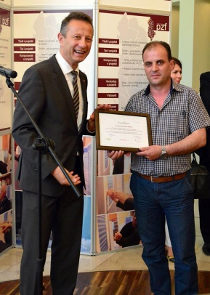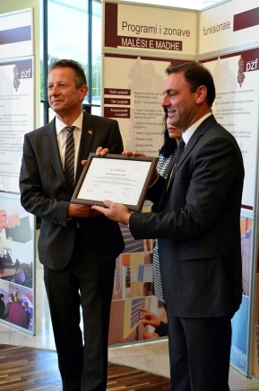

1. Municipality of Lezhë (Lezhë Functional Area Program);
2. Municipality of Kukës (Lezhë Functional Area Program).

Award Certificates were presented by H.E. Mr. Christoph Graf, Ambassador of Switzerland in Albania, respectively to Mr. Viktor Tushaj, Mayor of Municipality of Lezhë, and Mr. Petrit Marku, Mayor of Commune of Kallmet, and to Mr. Fasli Teta, of Municipality of Kukës.

Prizes consist of a sum of EUR 5.000 for each of the winner Municipalities.

### Best FAP implementing organizations’ awards

Awards were presented also to the FAP implementing organizations. Three awards were given to three out of eight organizations which have worked for the preparation of the Functional Areas program Document in 8 Functional Areas. Implementing organizations had the chance to select among each other the best organizations, through a voting process. Awards were presented to:

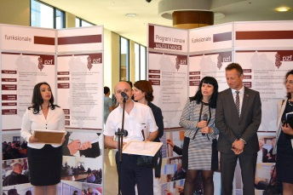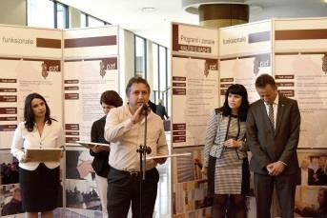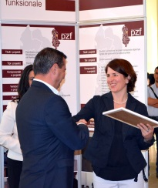

1. First Place – Dea Studio, represented by Mr. Antonin Braho, implementer of Mat Functional Area Program;
2. Second Place – ALCDF, represented by Mr. Besnik Alku, implementer of Dibër Functional Area Program;
3. Third Place – ANTTARC, represented by Mr. Myftar Doçi, implementer of Tropojë Functional Area Program;

Award Certificates were presented by H.E. Mr. Christoph Graf, Ambassador of Switzerland in Albania, and Mrs. Debora Kern, SDC Regional Adviser. Prizes consist of a sum of EUR 2.500 for each of the first and second places and a sum of EUR 1.000 for the third place.

### Functional Areas Programs Exhibition

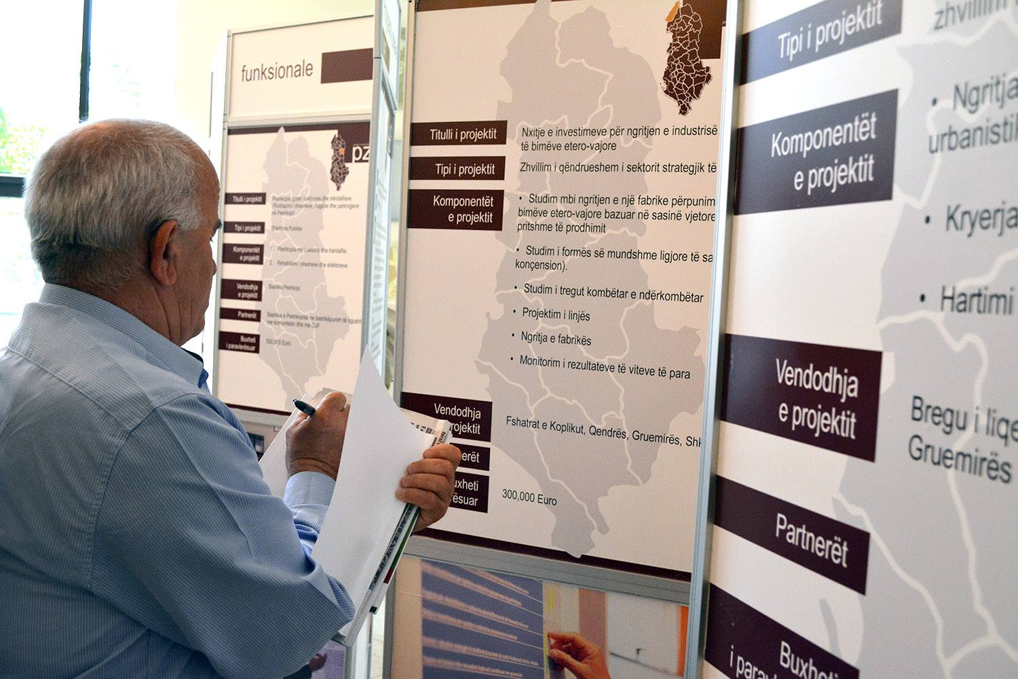An exhibition of the three best ranked projects for each Functional Area Program was presented to the participants of the Conference. Identified projects were submitted to a public voting, including different interest groups as well as citizens. Local businesses and elected officials, in each functional area had the opportunity to express their view regarding the new territory of their municipality, through ranking the identified projects. A technical jury at the local level evaluated the projects identified through FAP. The jury, in each functional area was composed by representatives of Prefecture, of the Qark and of the three core LGUs in the functional areas. Participants in the Conference were distributed copies of the projects’ catalog for each Functional Area, as well as the Methodology developed by dldp for conducting Functional Area Program.

# Session 3: (parallel sessions) local planning & organizational development

The third Session was dedicated to two important topics addressed by the Functional Areas Program: (a) Local Planning, and (b) Organizational Development. Each of the topics attracted the interest of the participants. Both Sessions had the concept of discussing platforms, with panels composed of high institutional representatives, experts and dldp.

## Session 3A: Local Planning

Session A dedicated to Local Planning was chaired by Mrs. Eglantina Gjermeni, Minister of Urban Development. The panel was composed of:

* Mr. Arben Kopliku, dldp’s Deputy Program Manager;
* Mrs. Eglantina Gjermeni, Minister of Urban Planning;
* Prof. Stefan Pfaeffli, University of Luzern in Switzerland;
* Mrs. Rudina Toto, PLGP expert;
* Mr. Blendi Bushati, dldp expert;
* Mr. Artur Kurti, STAR/UNDP;
* Mr. Nertil Jole, Ministry of Urban Development.

Minister Gjermeni set the frame of the session and presented the objectives. She pointed out that Ministry of Urban Development has started three initiatives:

* Initiative for a General National Plan;
* Initiative for the Integrated Plan for the Seaside;
* Initiative for the Tirana – Durrës (Durana) Economic Area Plan.

We expect that such initiatives are brought forward also with the assistance of our partner programs such as PLGP, GIZ, and dldp, as to ensure the combination of domestic and international expertise. Such initiatives will of course contribute to the economic and social development of the country.

We will support the local government. The new 61 Municipalities shall face a number of challenges because of the increased responsibilities to manage a wider territory. The Mayors will be looking for development plans for a territory that combines rural and urban areas. The first challenge that these new Municipalities will face is to know the territory, to have at hand an analysis of their potentials and resources and prepare plans be them strategic plans or local plans. Together with the National Agency for the Territory and PLGP, we have started to prepare the platform to support Mayors in their development plans. We had the opportunity to see here the Functional Area Program, which has been implemented with concrete results in a number of new Municipalities. We are very open for collaboration and use FAP combined with our approaches in the planning processes we have started.

In introducing the following presentation, Mr. Gjermeni said that: The session serves as a platform for sharing the experience and the good practices developed by dldp in applying the FAP approach and how can we harmonize the different approaches in our efforts for a better strategic planning of the territory as contribution to social and economic development.

### Presentation: FAP vs Strategic Planning and its methodology

Prof. Stefan Pfaeffli of the University of Luzern in Switzerland and Mr. Blendi Bushati, dldp’s expert on the Methodology of FAP, held a presentation on confronting FAP with the Strategic Planning and its methodology.

The principle of Functionality in Territorial Policy was analyzed through presenting firstly the disadvantages of fragmented territories: *Inefficiencies* (fixed costs to high, spill-over effects, coordination problems especially in case of network-infrastructure); *Development potential* of areas not fully utilized; *Positioning of areas* too weak. Such disadvantages bring the necessity for an Administrative and Territorial Reform.

Principle of Functionality is used for TAR:

* Economic and social activities take place in space (areas) reaching beyond historical borders. Areas with intense socio-economic activities are considered as functional areas.
* When TAR takes place in order to overcome the disadvantages of fragmentation, it should make sure that administrative borders better harmonize with functional areas.
* Principle used for TR in Switzerland, Germany, Ireland, Spain. Promoted by OECD and EU (mainly for urban areas).

It has been explained that the idea of FAP comes from the Swiss Agglomeration Program. Thus a comparison between FAP and Strategic Planning was presented.

|  |  |  |
| --- | --- | --- |
|  | **FAP** | **SP** |
| Territory | FA | Existing LGU |
| Scope | Narrower focus: regional development and local service delivery gaps and modalities | Broader focus: covering all LGU-functions |
| Time horizon | Transition period, ~4 years | ~10 Years for on-going (local) governments |
| Approach | Expert-based, less participative | Stakeholder- based, more participative |
| Implementation | Functional Area Methodology | SDPeMTBP followed up by Urban Planning |
| Responsible institutions: | LGU-s and Agency for Territorial Reform implementation | LGU-s and MUD/MoF and DSFAP |

Adoption & Implementation of FAP was presented as a more realistic Scenario, through a number of arguments/assumptions, providing also a sequential set of actions laid down in a timeline. The basic idea is that instead of going for a Strategic Planning exercise, new Municipalities should opt for implementing a Functional Area Program exercise.

A general overview of FAP as a product was presented, focusing in the main features. The Functional Area analysis touched three areas: (i) Economy of the functional area; (ii) mapping of the services; and (iii) local government analysis. Scenarios build upon analysis of various economic sectors and subsectors, were the main issues at stake, associated with illustrations of data and figures. The same logic follows concerning services. Conclusions and recommendations based on analysis provide a sound basis for further development.

Development of FAP included **Functional area projects** on the economic development and integration as well as improvement of public services, aiming to strengthen the internal cohesion of the FA as well as to make use of the expected benefits of delivering joint services. Structures and processes of the implementation of the FAP including recommendations for the **organizational setup of the new LGU** were also part of the process**.** Identification of projects was based in the analysis and recommendations, for three categories: economic development, service optimization and quick start projects.

|  |
| --- |
| FAP: The process – Key steps |
| Discussion and agreement of the idea  with political actors |
| The Functional Area Analysis |
| Identification and preparation of key projects |
| Recommendations for new LGU organization |
| Communication strategy |
| Finalization and approval |

Key actors involved in the FAP implementation as well as methodological hints were also presented.

### Interventions from panel members

**Mrs. Eglantina Gjermeni,** **Minister of Urban Development:** I consider the FAP Methodology and the analysis carried out as fitting into the territory planning frame and the plans, policies and regulations that the Ministry is preparing, concerning the territory. Having at hand the FAP Methodology, will facilitate the new Municipalities in developing their strategic plans.

**Mrs. Rudina Toto, expert of PLGP**, pointed out the need for a comparative view between Strategic Plans and Functional Areas Program, in order to see how they stand versus each other and how can they support each other. Territory planning is first of all a statutory/legal system. Local authorities have to use planning instruments, such as territory planning, which despite the fact that allow certain methodological freedom, have also a number of criteria to be met. Territory planning is a long term and quite complex cycle, which start with a strategic thinking and the institutional/legal set up and is concluded with the process of construction permits. The Functional Areas Program is part of another group of instruments, which stand at a more strategic level and do not fully meet the legal requirements of the territory planning law. This feature makes these instruments more dynamic, more flexible to adapt to various situations and political, economic and social contexts. For this very reason FAP should be promoted.

FAP refers to territories which belong now to the new Municipalities, hence when speaking for territory planning or other development instruments within the functional areas we are speaking about new LGUs. I see two uses of the FAP methodology: (i) use as a methodological concept within the frame of territory planning; and/or (ii) use it as a short term instrument addressing the challenges and priorities of the new Municipalities.

Starting from the second point, I would like to point out that the new territories do not have any proposed or inherited instrument at hand; hence an instrument as the Functional Areas Program is quite helpful in achieving results. On the other side we have the Territory Planning as a legally binding instrument, which follows certain timelines. New Municipalities will not be able to develop them in short term, as strategic plans will be needed to be prepared first. So it will take 1 to 2 years to do that and Municipalities cannot wait for this time frame to start knowing their territory. As a result I believe that Municipalities should start immediately the process of territory planning and harmonize it with FAP as a more flexible instrument. I believe that FAP should be the first to be prepared and afterwards the Municipality may choose how to harmonize both instruments, and at the end should be finalized with the Territory plan as part of the LGUs function for management of soil and issuing construction permits.

**Mr. Artur Kurti, of STAR/UNDP**, praised FAP as a development instrument. We are just in time to promote this instrument as we are in the electoral period and we can listen to candidates making promises without solid basis, as they do not know the budgets of the Municipalities, their funding possibilities, etc.

I believe that Functional Areas program should be introduced in the law and be regulated by law. From the STAR prospective I can say that there are a lot of issues which should be regulated by law. On the other hand I would like to stress the necessity that priority is given to projects which are afforded by the own resources of the Municipalities or implemented through a public-private partnership. Most of the identified projects by FAP are addressed to various funding institutions, mainly by the Regional Development Fund and the central government funds.

What I think is the most important issue, is the awareness rising of the candidates or the new elected Mayors for acknowledging the importance of Forums that have been involved in the FAP implementation.

**Mrs. Eglantina Gjermeni,** **Minister of Urban Development,** reiterated the proposals of Mr. Kurti that FAP be introduced as a legal instrument. As the regulatory framework is at the initial phase, there exists the possibility for such action. On the other side, I agree that candidates should make FAP part of their political electoral platforms, basing their promises in the potential and resources of their new territories.

**Mr. Antonin Braho, expert involved in FAP implementation**, pointed out that the implementation of FAP in Municipalities of Burrel and of Klos presents the case of inter-LGU cooperation. Besides the challenges to the local level, the national level faces also a number of them. Firstly it is necessary to establish a system for gathering data on the territory. I believe also that the national level should use FAP as an instrument for identifying the intervention sectors, as may be the case for the Ministry of Agriculture for example.

**Mr. Luan Dervishej, expert of GIZ**, stressed that reflecting on the identified projects a first challenge is the structuring of the administration in new Municipalities as to respond to the priorities of the territories. We are still far from establishing practices and instruments which will support the efforts for assuring social and economic welfare at the local level.

### Findings and Recommendations of Session 3A

Findings and Recommendations of the Session were made by Mr. Nertil Jole, Ministry for Urban Development.

* The Conference serves as a support to new Mayors and Administrators to face the challenges presented by the implementation of the Territorial and Administrative reform;
* Presentation of the concept of functional areas program is a positive step leading to the necessity to conduct territory analysis
* This process is very valuable for the knowing of the territory. It has the appropriate flexibility to be considered as a basis for analysis which serves to build strategic planning processes, which are a first step towards the realization of the general local plans.
* Actually only 0,3 % of the Albanian territory is covered by local plans, which are subject to review after the implementation of the TAR. One of the challenges put forward is the harmonization and integration of urban and rural spaces, processes that are not considered adequately by the actual plans.
* These Functional Areas Programs will serve to new Administrators for starting their work.
* Considering the necessity to prepare general local plans in a short period of time, FAP is a model to be used as well by those Municipalities that have not conducted such an analysis.
* Ministry of Urban Development and the National Planning Agency, in coordination with PLGP, have established a working group for the preparation of a platform which will come to the aid of the new Municipalities and facilitate the complexity of such process, in the frame of the preparation of local plans.
* Recommendations made on the basis of the projects identified in the frame of FAP should be considered within a wider dimension for assuring appropriate funding. The effects of such projects should be seen not only at the local level but also at the regional level, thus making these projects more competitive and eligible for funding by the Regional Development Fund.
* Despite the political will for providing as soon as possible a solution to fill in the gap created by the lack of local plans, it is quite necessary to underline the importance of the qualitative dimension of this process. The economic analysis is very important to be carried out because it serves as an instrument which enables the acknowledgment of the territory.

## Session 3B: Organizational Development

Session B dedicated to Organizational Development was chaired by Mrs. Albana Koçiu, Director of Department of Public Administration. The panel was composed of:

* Mr. Erton Kashta, dldp’s Deputy Program Manager;
* Mrs. Albana Koçiu, Director of Department of Public Administration;
* Mr. Artan Shkëmbi, Director of the Agency for Territorial and Administrative Reform Implementation;
* Mr. Artan Rroji, CoE expert;
* Mr. Altjon Paloka, STAR/UNDP;
* Mr. Enea Hoti, Adviser to Minister of State for Local Issues;
* Mrs. Sabina Ymeri, ISB, dldp expert;
* Mr. Endri Xhina, ICT solution, dldp expert.

Mrs. Koçiu set the frame of the session and presented the objectives. She expressed the gratitude towards the donors’ community and dldp, for the support offered in this particular moment of reorganization of the LGUs. It is a great challenge. There are two main strategic documents guiding the process: (i) Cross-cutting Strategy for Public Administration Reform 2015-2020; and (ii) Cross-cutting Strategy for Decentralization and Local Governance. Overlapping of responsibilities and tasks between LGUs and de-concentrated agencies is another challenge. All need to respond efficiently to the TAR, by creating structures which respond to citizens with a clear structure, a clear hierarchy and a clear division of responsibilities. The Civil Servant Law provides a good basis for this purpose. Training remains one of the main issues to be addressed.

### Presentation: Organizational chart of the new LGUs: learnings from FAP and practices from the Integrated One-Stop-Shops exercise.

Dldp’s experts Mrs. Sabina Ymeri and Mr. Endri Xhina presented their findings and learnings from two important exercises: Functional Area Program and Integrated One-Stop-Shop (IOSSH). FAP has identified a number of challenges concerning the organizational structuring of the new Municipalities:

* Increased diversity in the territory;
* Diversity of services;
* Range of services to the citizens;
* Space for increased role of the Municipality for the development orientation.

Municipalities may play a more pro-active role in development, as promoter and facilitator. Identification of sectors with higher potential for development in the new Municipalities should accelerate the opportunities for growth, not only by creating conditions and enabling the infrastructure, but also through innovative projects, multipliers of local / cohesion growth. However, such a role of the Municipalities is enabled by certain conditions, such as: change of mentality at the local level; technical expertise and increase and standardization of services.

Comparing the typical actual structures of LGUs with the need for change, experts come up with a proposed structures delineated in four pillars:

* **Development policies** (Strategic planning of economic and sectorial development; social and economic cohesion; service policies and standards; assessment and forecasts; Territory planning and Planning of social and cultural issues.
* **Regulatory tasks** (Processes of licenses; permits; accreditations; and inspections. *These functions should be separated by the process of definition of regulations (policies) and by the direct services.*)
* **Service Delivery** (Services to the community (cleaning, maintenance of infrastructures, etc.; direct services to citizens).
* **Support services** (Finance; Income; Legal services; Procurement; Human resources; ICT).

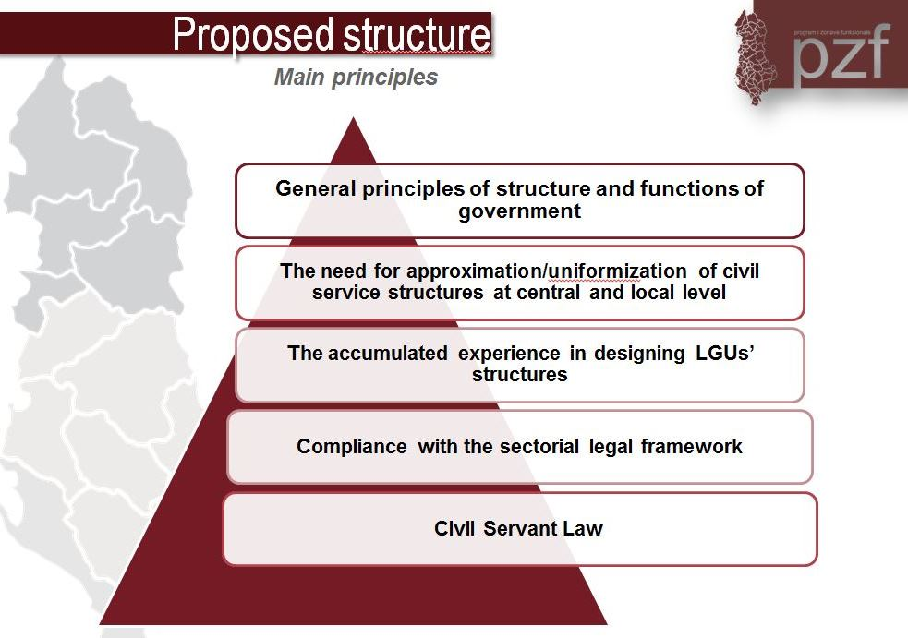A proposed structure of the new structure should follow some main principles.

More in concrete, it is proposed the introducing of the position of the Secretary General in the Municipality structure, as an interconnection point between the political level and the administrative level.

The “Cabinet of the Mayor” is seen as well as a necessary unit, providing advice and support to Mayors.

On the other hand a Direct Services Units is recommended to be established for the connection of new Administrative Units within the frame of service delivery to citizens.

Correlating also the experience from the Integrated IOSSH exercise, the actual offices within the administrative structure of the LGUs, are distributed within the four pillars proposed for the new organizational set up, considering also the workload for a period of one month as resulted from the interviews with LGUs done in the frame work of the IOSSH study. A double situation has been noticed, which refers to non-digitalized service scheme and partially digitalized service scheme. Hence a structural scheme adapted for the transitional phase has been presented, demonstrating the transformation of job positions and necessary skills and capacities of employees.

Presentation was closed with a schematic hint on where to orient organization and strengthening of capacities under the new context.

WHERE TO ORIENT ORGANIZATION AND STRENGTHENING OF CAPACITIES UNDER THE NEW CONTEXT?

### Interventions from panel members

**Mr. Artan Rroji, expert of Council of Europe (CoE),** engaged in various studies with local government administration, appreciated the fact that dldp has maintained a quite clear approach to the organizational structuring of the new Municipalities. He stressed that the Civil Service Law (CSL) gives quite an authority to Mayors in terms of administrative structures determination. CoE has also been active in CSL implementation, establishing a help desk to this purpose. CoE has an inventory approach trying to understand which are the functions and the staff in LGUs; which are the new positions and the respective staff, followed with the needs for training. The Mayor will approve the new structure aided by the HRM unit, thus there will be one structure for the definition of the political and development objectives, and another one for the implementation of the legal requirements (organic and standards). The proposal made here concerning the Secretary General position, is appropriate. Even though the CSL does not expressly mention such position, it provides for a manager position which makes the connection of the policymakers with the executive branch. To our opinion, the administrative structure should not be oriented only towards the local services, but as well as towards local democracy, thus enabling local democracy and strategic development. Greater natural resources in the new Municipalities will provide the opportunity to play a greater role in the social, economic, cultural and environmental development as well as for the provision of more efficient services in line with standards.

**Mr. Altjon Paloka of STAR/UNDP** stressed that the program has identified two critical moments to be taken into consideration, in the framework of support to TAR. The first moment concerns the after-election period, when needs for an administrative and financial consolidation will emerge. While the second moment concerns the administrative structures of the territorial units.

The project thinks that new structures are needed not only in the Municipalities and the Administrative Units, but as well in subjugated, de-concentrated institutions, which need to be assessed and restructured as a consequence of TAR implementation. Functions of the new Municipalities are for the major part defined in the organic law of local government. The exercise of such functions is provided for by the sectorial laws and secondary legislation. Roles, processes, job descriptions of the positions in the new Municipalities and Administrative Units, both political and civil, should be guided by the respective plans and policies approved by municipal councils. As concerns the delegated and shared functions, Municipalities should harmonize their actions with the central government (through decentralized agencies).

**Mr. Enea Hoti, Adviser to Minister of State for Local Issues (MoSLI)**, stressed the fact that the Government, coordinated with the donors’ community has made the issue of service delivery to citizens, a priority. Technology comes to our aid for overpassing the gap that might be created between the center of the Municipality and the Administrative Units. Dldp has since a long time now initiated a good job to this regard and in few days its model will be presented in practice. MoSLI aims that the model of IOSSH is applied in all LGUs, which means that Municipalities will be more advanced than the central government. IOSSH represent a huge step forward in the modernization of service delivery, and we thank dldp for this initiative. We hope that such good practice is used as a model in the other Municipalities.

**Mr. Artan Shkëmbi, Director of the Agency for TAR Implementation (AZRT)**, explained that this institution has the responsibility over the process of passing from 373 to 61 LGUs. AZRT supports the process and is the main beneficiary of the projects supported by the donors (dldp, KE, STAR, etc.). The Conference of today provides us some clear ideas on what is to be done on the future. The organic law is changing. The administrative structure is done by the Mayor, and the Mayor will need help and support. That is why we are in a quite complex situation, which needs simple, concrete and practical proposals. I am glad to see that dldp has presented concrete proposals, such as the case of the Secretary General. I think that there should be a legal amendment to introduce the position of the Secretary General in all LGUs. It is of outmost importance to work on administrative structures not only for the center of the Municipality, but also for the Administrative Units, which vary in territory and population, in urban and rural, in mountains or in flat areas. This way we could have several variants of administrative structures to share with the new Mayors. We are actually working on a model of administrative structure, which will be applied after the local elections, and the in the period June to December 2015, the new Mayors will have the possibility to adapt it according to their needs.

### Findings and Recommendations of the Session 3B

Findings and Recommendations of the Session were made by Mrs. Albana Koçiu.

* The very first day Municipalities will have in hand a model for their organization and functioning. We need further on to set standards on the number of employees in such structures;
* It is obviously necessary to develop a standard form of the structure, while the Mayor shall have the power to assess the specific weight depending on the specificities of the territory and the respective strategies;
* Along with the model structure, it is necessary to prepare a manual on working procedures, on how they are correlated and how services are offered to the citizens. Efficacy and efficient structures, with clear and divided positions are needed;
* Preparation of models for ToR for the Administrative Units, their organizational and procedural set up, would be very helpful in jointly steering the recruitment process;
* There should be prepared a guideline on CSL implementation. Structures are obviously strengthened, but they need also training and capacity building;
* Implementation of CSL takes great importance as it is related to the job classification and respective salaries’ system. There is a methodology based on points which needs to be implemented, through a process which needs a practical guideline;
* The role of the Secretary General is already in the law and it is functional;
* Secretary General vs Administrator – it has worked in the past in the Municipality of Tirana, and I believe we all agree on the introducing of the Secretary general position;
* We all agree also on the need for strengthening of the communication structures with the citizens, hence the integrated one stop shops;
* Another element of the CSL is the management of the Register of Personnel. It enables the in-job performance management;
* There is a need for strengthening the capacities of the ICT structures;

# Annex 1: Program of the Conference

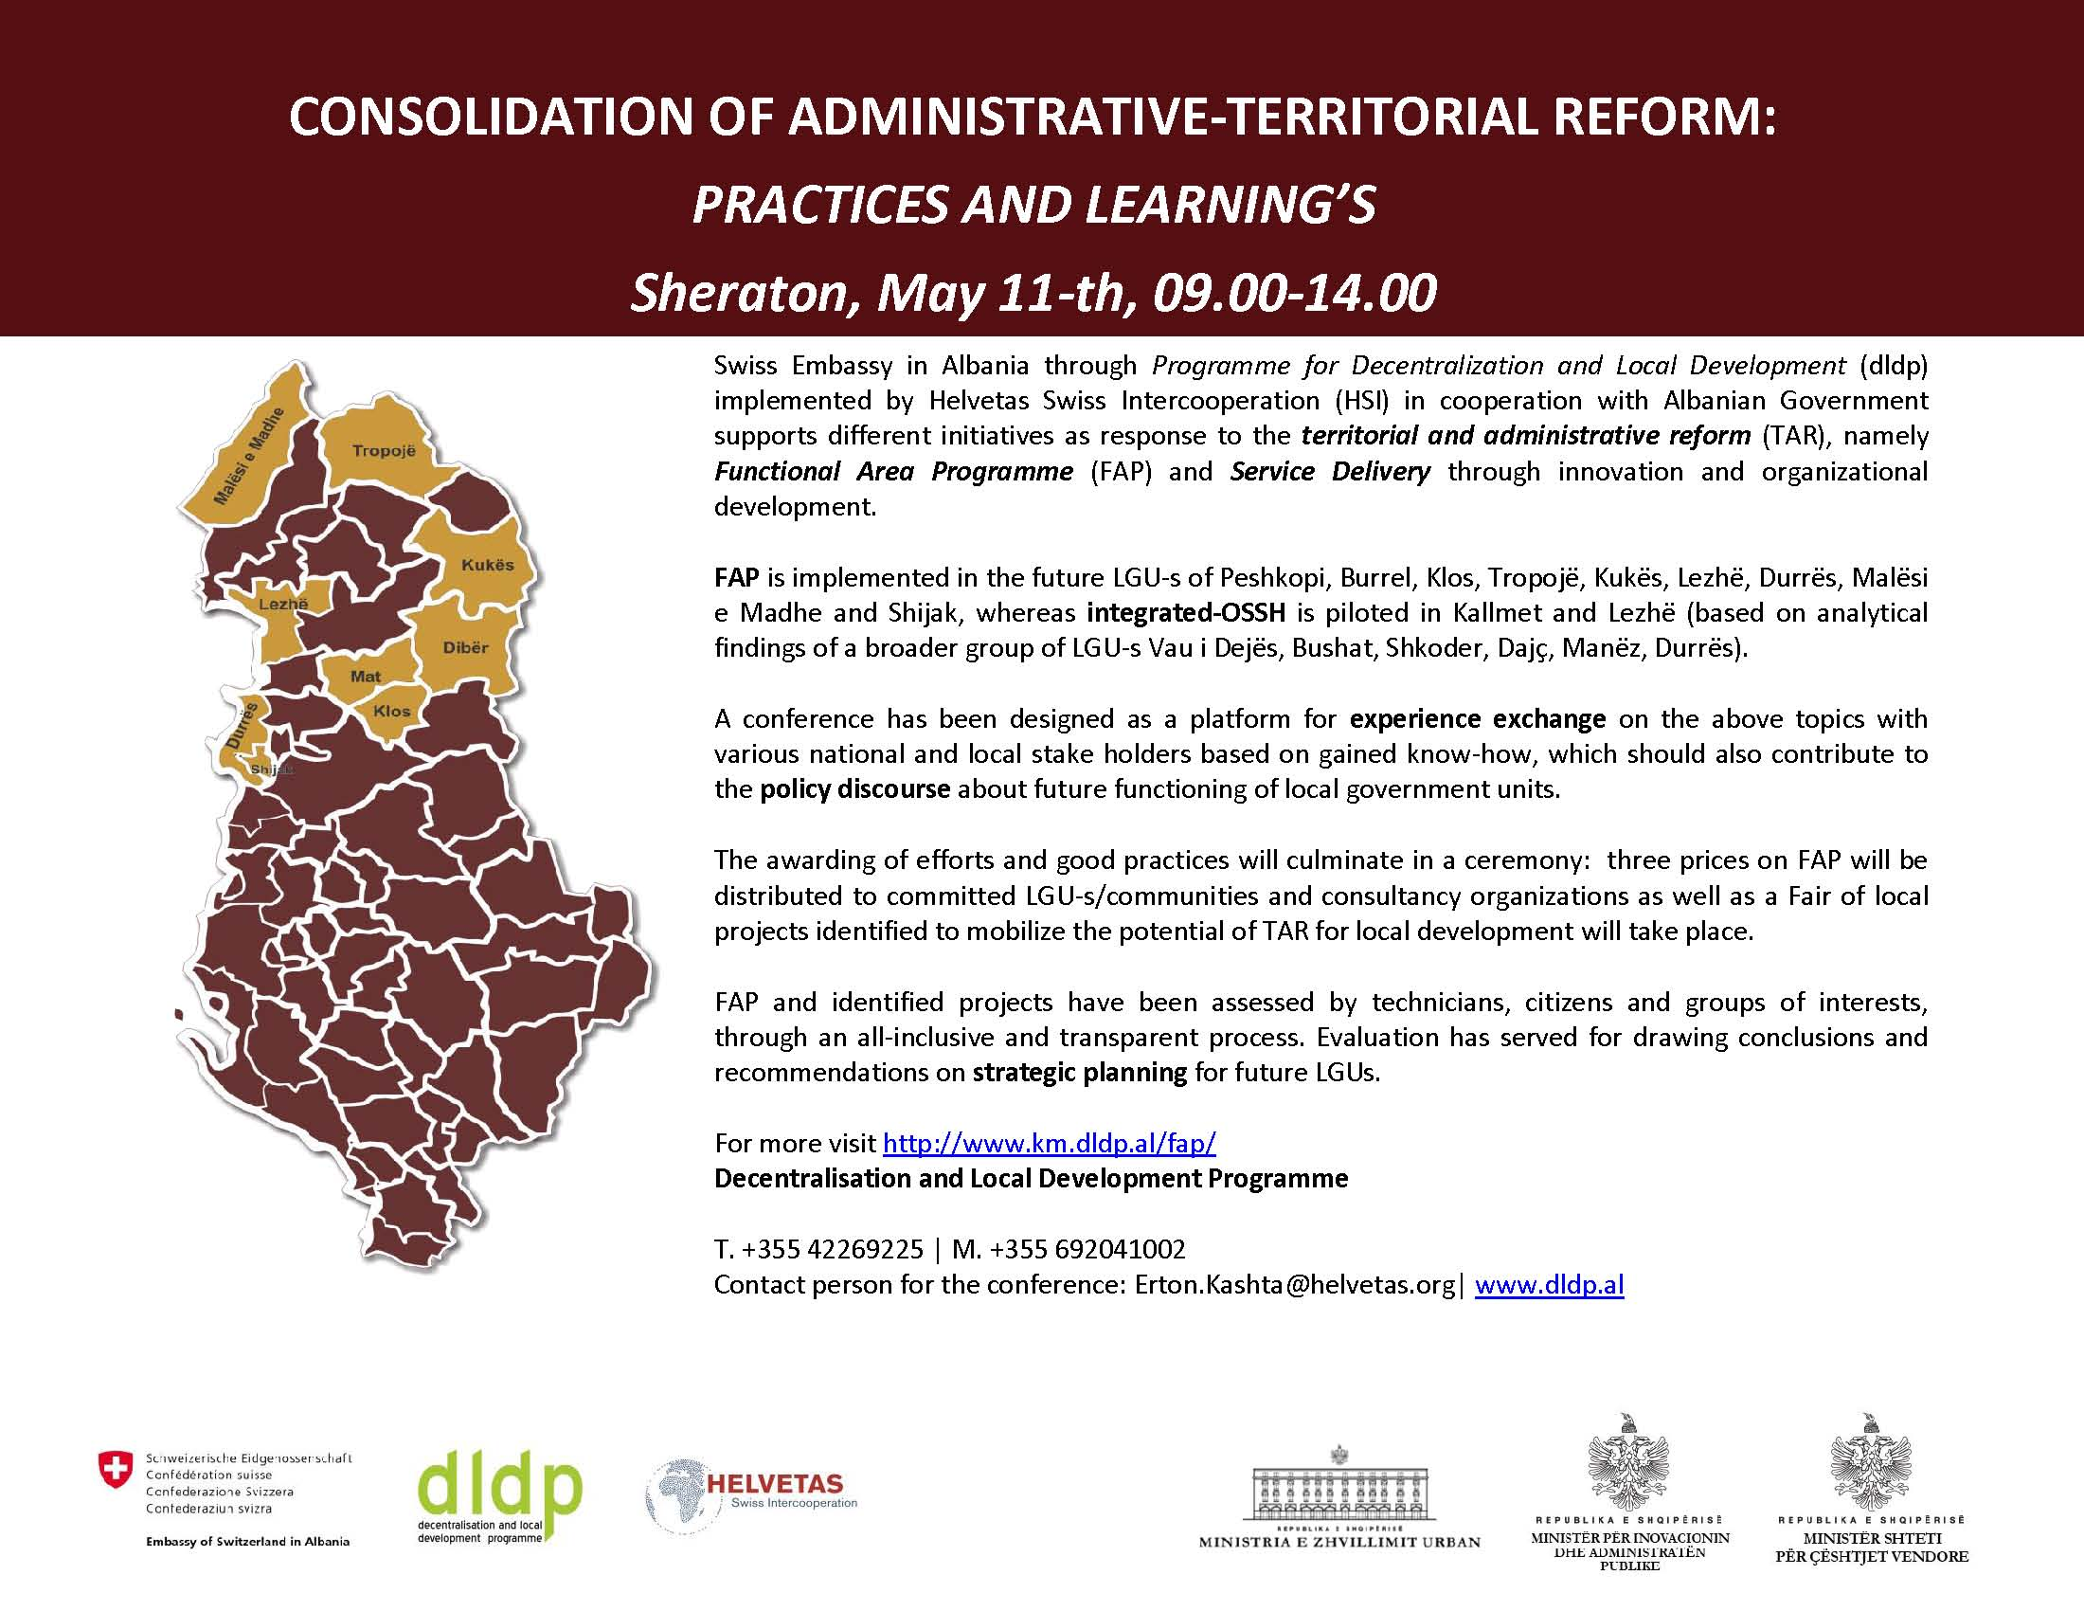

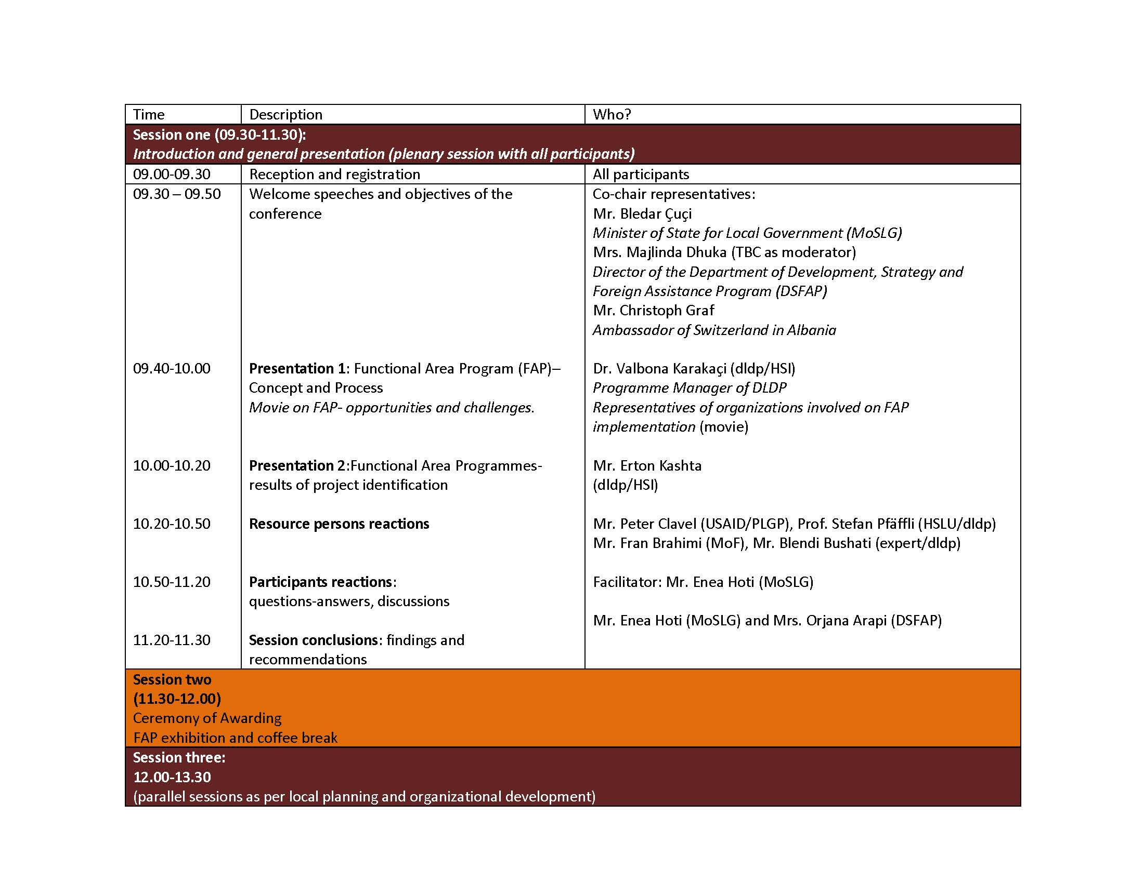

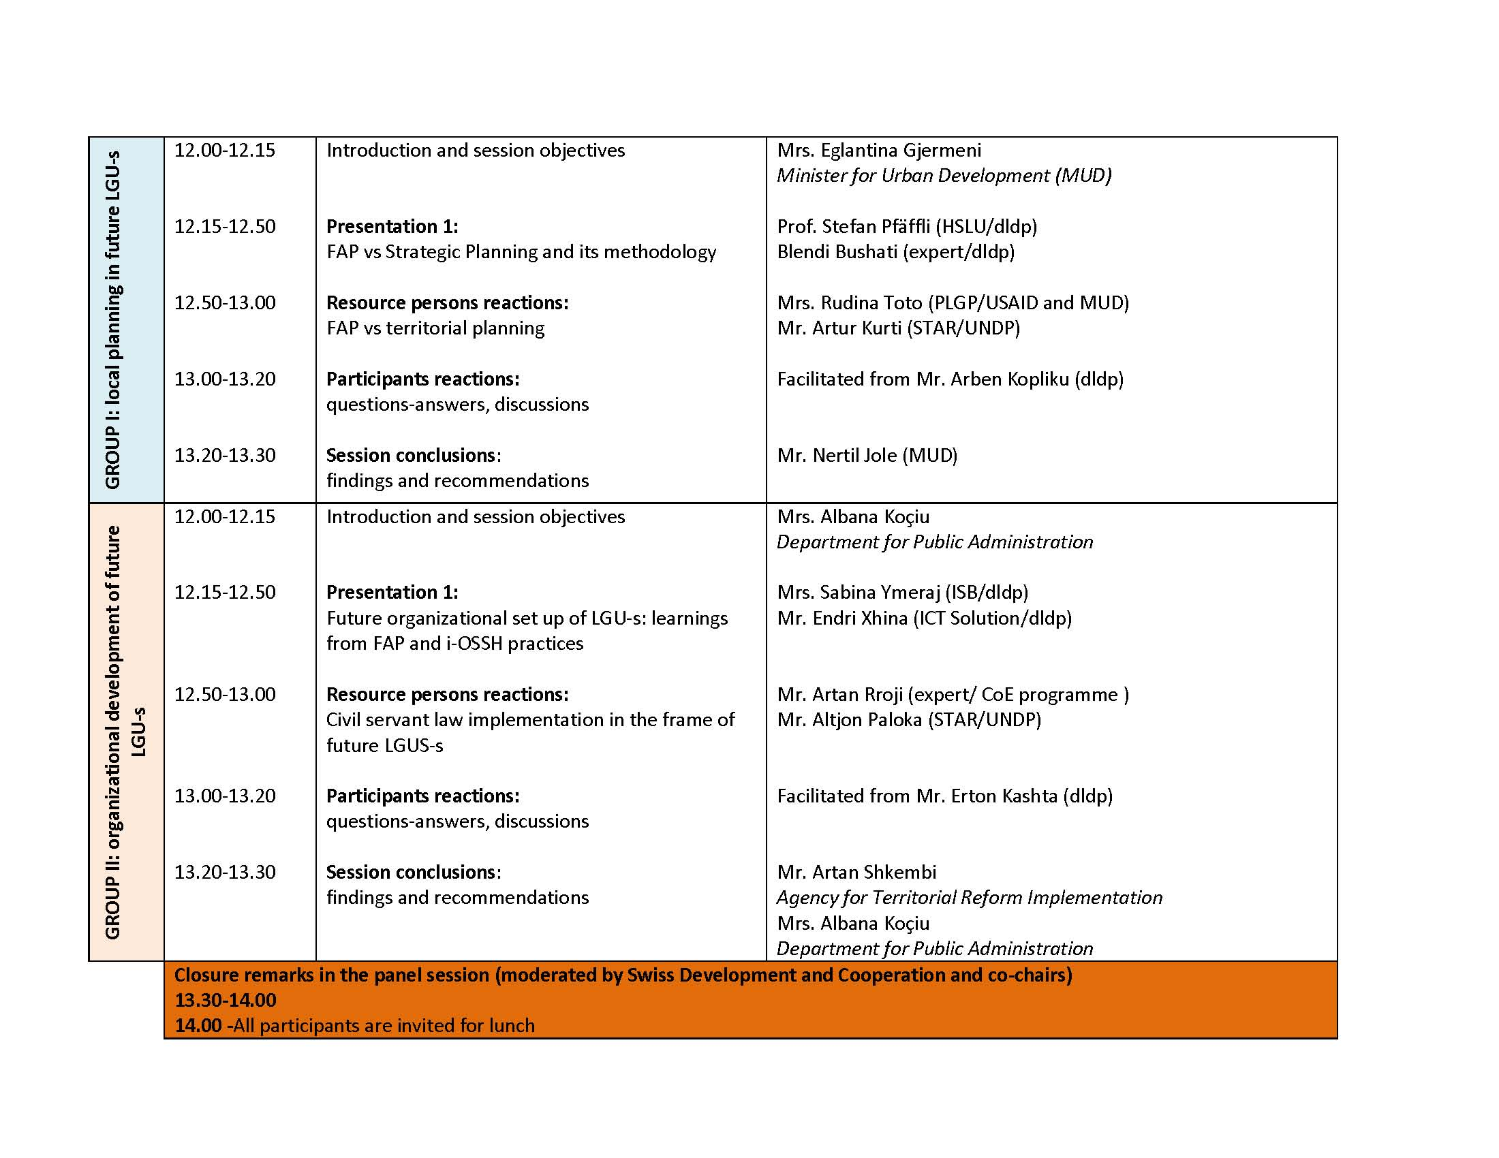

# Annex 2: Resources

1. Presentations:

* Functional Areas Program, by Dr, Valbona Karakaçi

<http://www.km.dldp.al/wp-multimedia/fap/conference%20presentation/Valbona%20presentation%20in%20Engl.pptx>

* Movie on FAP - <https://www.youtube.com/watch?v=AhIJGhnhnls&feature=youtu.be>
* Functional Areas Projects – Results of projects’ identification, by Erton Kashta - <http://www.km.dldp.al/wp-multimedia/fap/conference%20presentation/Erton%20Presentation%20EN.pptx>
* FAP-Methodology and implementation – by Prof. Stefan Pfaeffli & Blendi Bushati - <http://www.km.dldp.al/wp-multimedia/fap/conference%20presentation/Stefan%20and%20Blendi%20presentation_Blendi_ANG%20OK.pptx>
* Future organizational set up of LGUs: learnings from FAP and Integrated OSSH practices, by Sabina Ymeri, Endri Xhina - <http://www.km.dldp.al/wp-multimedia/fap/conference%20presentation/Sabina%20Endri%20presentation%20EN.pptx>

1. Publications:

* Methodology of Functional Areas Program: <http://www.km.dldp.al/wp-multimedia/fap/english/FAP_Guidelines_2104_draft%20final%20English.pdf>
* FAP Dibër (Program document and identified projects):

<http://www.km.dldp.al/diber/?lang=en>

* FAP Durrës (Program document and identified projects)

<http://www.km.dldp.al/durres/?lang=en>

* FAP Kukës (Program document and identified projects)

<http://www.km.dldp.al/kukes/?lang=en>

* FAP Lezhë (Program document and identified projects)

<http://www.km.dldp.al/lezhe/?lang=en>

* FAP Malësi e Madhe (Program document and identified projects)

<http://www.km.dldp.al/malesi-e-madhe/?lang=en>

* FAP Mat (Program document and identified projects)

<http://www.km.dldp.al/mat/?lang=en>

* FAP Shijak (Program document and identified projects)

<http://www.km.dldp.al/shijak/?lang=en>

* FAP Tropojë (Program document and identified projects)

<http://www.km.dldp.al/tropoje/?lang=en>

1. Media

* Media announcement

<http://www.km.dldp.al/wp-multimedia/fap/Media-Release-dldp-conf-11052015.pdf>

* Pictures of the Conference

<http://www.km.dldp.al/konference-kombetare-konsolidimi-i-reformes-territoriale-dhe-administrative/>

* Videos of the Conference:

<https://www.youtube.com/playlist?list=PLs-ott7ZNS1C9fKNlBhxQldjBa-n63c2L>

1. <https://www.youtube.com/watch?v=AhIJGhnhnls&feature=youtu.be>